Pie chart
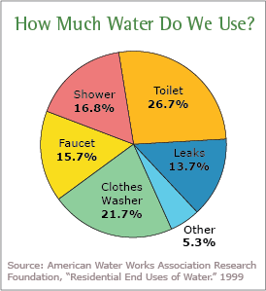
The pie chart illustrates the distribution of water usage among various activities. According to the chart, the largest portion of water usage is allocated to toilets, accounting for 26.7%. Following closely behind is clothes washing, constituting 21.7% of water usage. Showers represent 16.8% of water consumption, while faucets contribute 15.7%. A smaller portion, 5.3%, is attributed to other miscellaneous uses.
Line chart
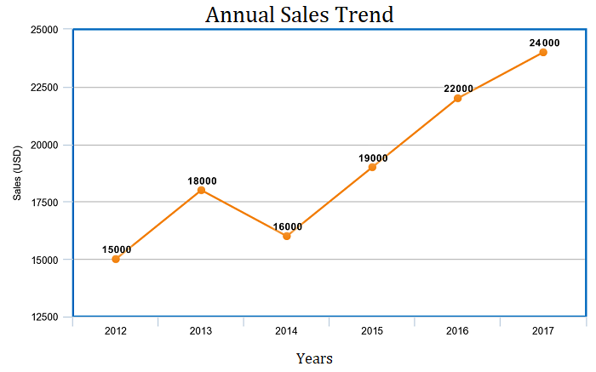
The line chart depicts the annual sales trend over the years. In 2012, sales amounted to 15,000 units. Subsequently, there was a noticeable increase in 2013, with sales rising to 18,000 units. However, there was a slight decline in 2014, with sales dropping to 16,000 units. The trend resumed its upward trajectory in 2015, reaching 19,000 units. Sales experienced significant growth in 2016, soaring to 22,000 units. Finally, in 2017, sales peaked at 24,000 units, indicating a continued upward trend.
Bar graph
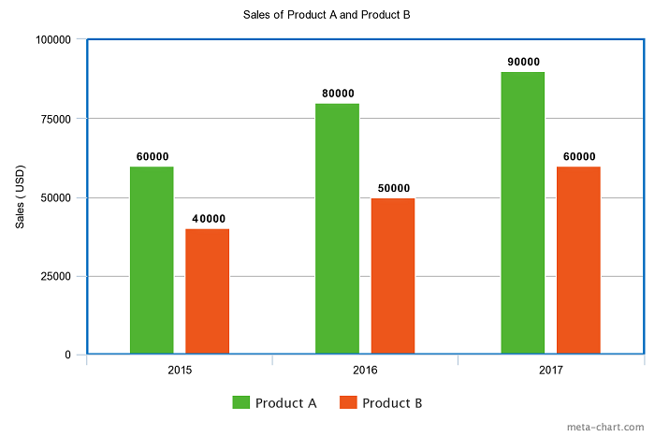
The bar graph represents the sales of Product A and Product B over the years 2015, 2016, and 2017.
In 2015, Product A sold 60,000 units, while Product B sold 40,000 units. This is depicted with two bars, where the bar representing Product A is taller than the one representing Product B.
Moving to 2016, the sales of both products increased. Product A sold 80,000 units, represented by a taller bar than its 2015 counterpart. Product B also experienced an increase in sales, reaching 50,000 units. The corresponding bar for Product B is shorter than that of Product A but taller than its 2015 sales bar.
Finally, in 2017, there was another increase in sales for both products. Product A sold 90,000 units, resulting in the tallest bar on the chart. Product B also saw an increase, reaching 60,000 units, represented by a shorter bar compared to Product A but taller than its 2016 sales bar.
Overall, the trend indicates a consistent growth in sales for both products over the three-year period, with Product A consistently outselling Product B by a significant margin each year.

